**Data Driven Testing**

1. What is Data driven testing?

Read the data from external recourse & run the test scripts is called Data driven testing (parameterization)

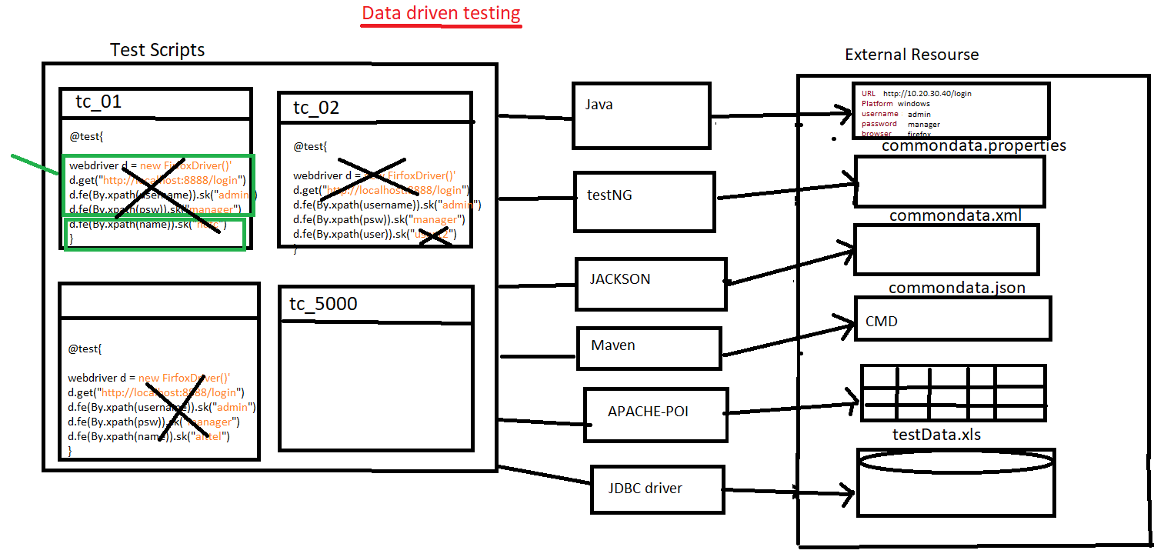

1. Why Data Driven testing?

As per the rule of the automation data shouldn’t not hardcoded because data modification & maintenance is tedious job when you want to run the test with different data, instead we should get the data from external resource like xlsx, properties file, database, XML, JSON, command

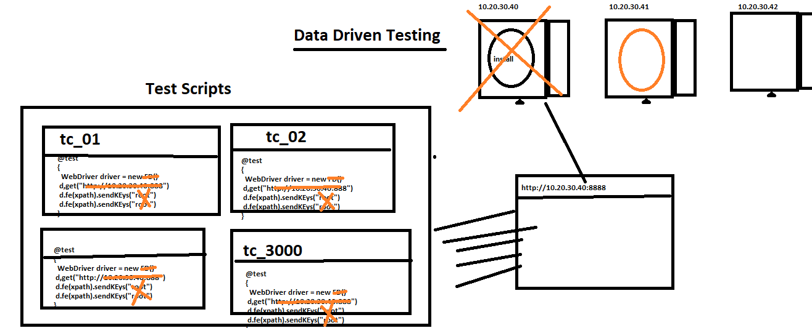

1. What is Advantages of Data driven testing
2. Maintenance of the test data is easy
3. Modification of the test data in external recourse is easy
4. Cross browser testing is easy (means change the browser in property File)
5. Running test scripts in different Environment is easy
6. Running test scripts in different credentials is easy
7. We can create the test data prior the Suite execution (we can also get the data from test Data team)
8. Rerunning test Script with multiple time is easy
9. **How to read data from properties File?**

* Get the java Object of the Physical file using “FileInputSteam”.
* Create an Object of “Properties” class & load all the keys.
* Read the data using getProperty(“Key”).

**Note**: properties file is light weight & faster in execution compare to Excel.

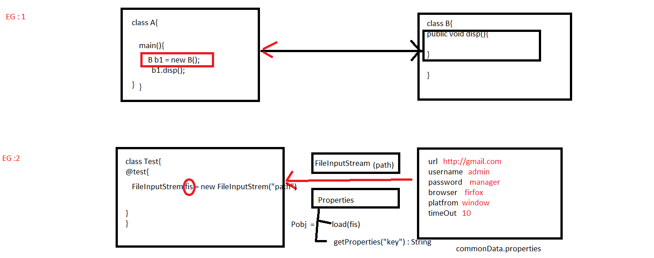

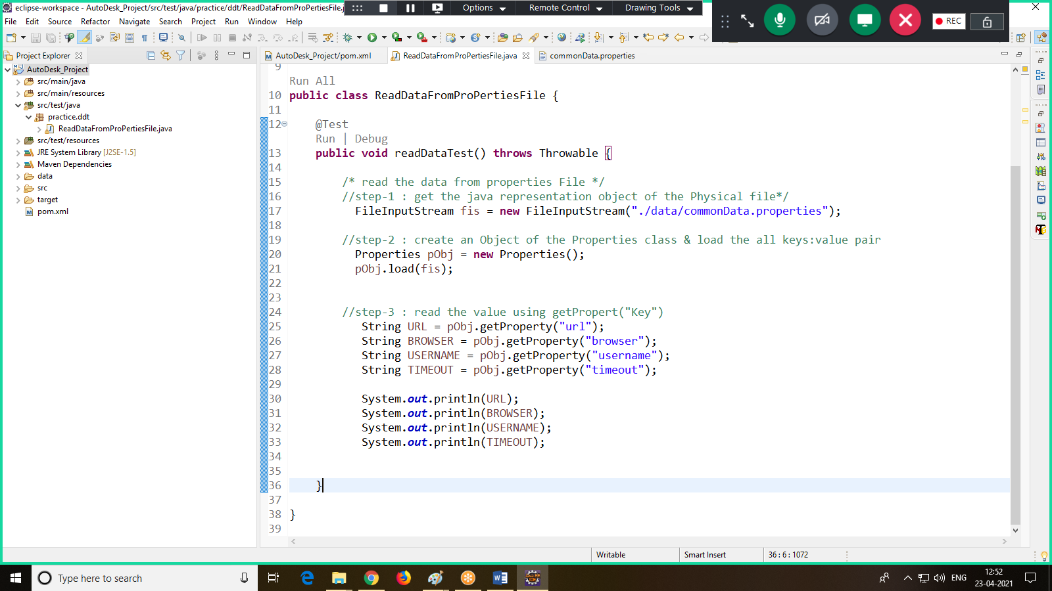

1. **How to read data from testing.xml**

Step1: write common data in XML file using <parameter>, data will be in the form of name: value pair

Step 2: using XMLTest class, we can read the data from testing.xml file

Step 3: make sure we always run the test via testing.xml file only

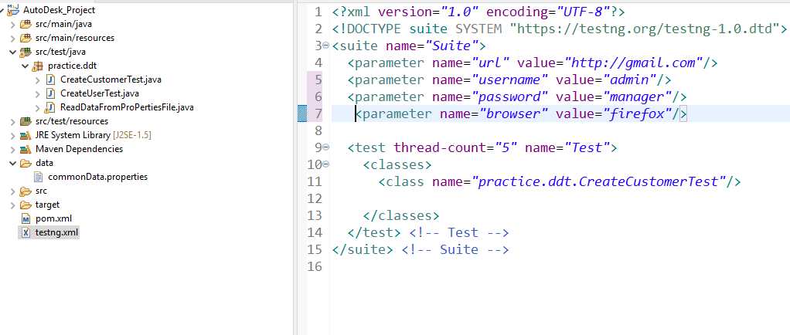

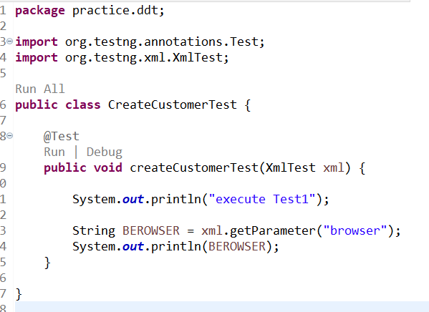

1. **How to read data from CMD using Maven**

Step 1: install maven Command-Line Software

1. Go to google, search for “download maven”
2. Click on first link
3. Click on “[apache-maven-3.8.1-bin.zip](https://apachemirror.wuchna.com/maven/maven-3/3.8.1/binaries/apache-maven-3.8.1-bin.zip)”
4. Download the .Zip file
5. Unzip the File
6. Get inside the “bin” folder.
7. Copy the location path

Ex: C:\Users\TYSS\Desktop\apache-maven-3.8.1-bin\apache-maven-3.8.1\bin

1. Go to local system “Environment variable” window.
2. We have to create 2 new variables in “user variable section”.

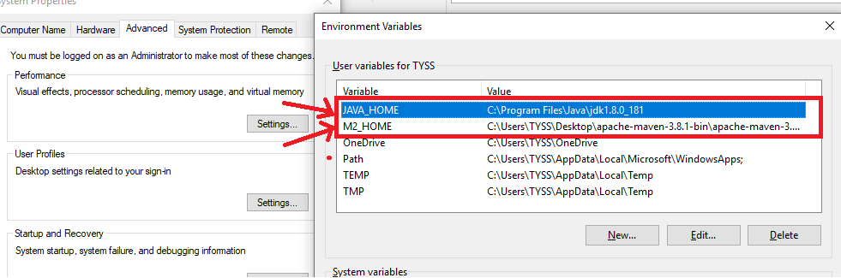

1. **We have to edit “path” variable in “system variable section”**

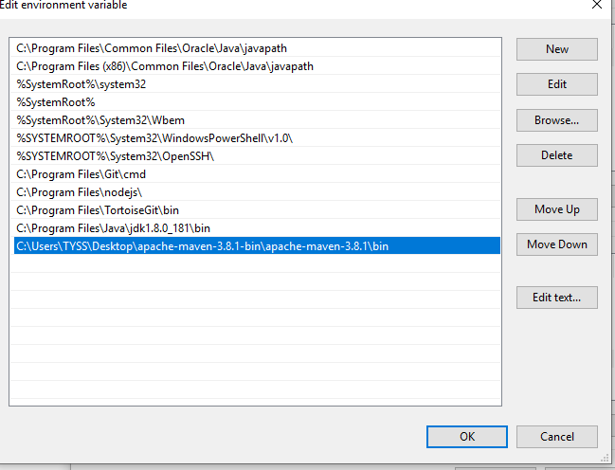

1. Click on “OK” in all the window

Step 2: In order to check weather software in installed or not ?

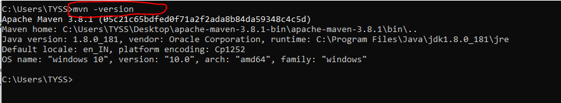

Step 3: pass maven parameter from the command line

1. Open command prompt
2. In Eclipse copy the location of the maven Project

Select project🡺 right click 🡺 properties 🡺 Copy the location

1. Go to command prompt, paste the location of the project

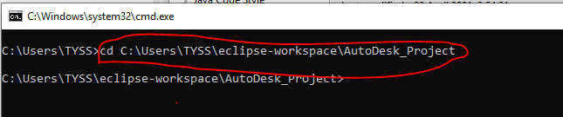

1. Execute maven command at the same pass the maven parameter using –Dkey=value



Step 4: java program to read data from maven parameter from the command line

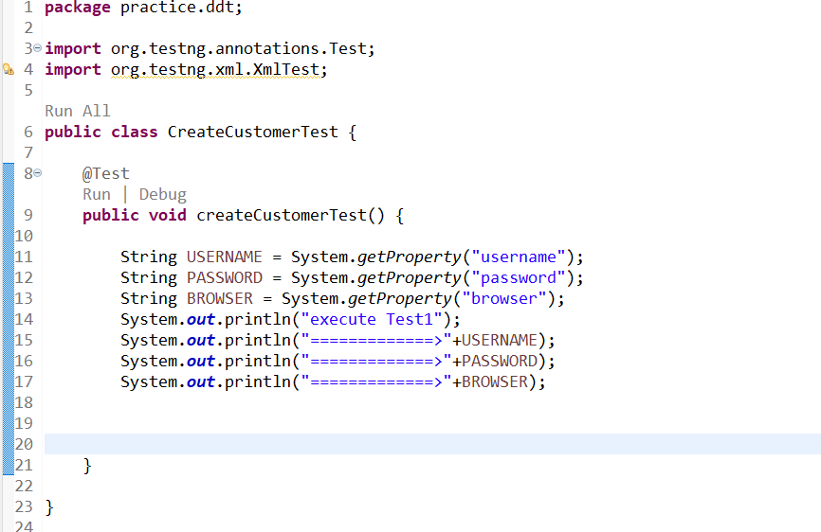

**How To Read Data From JSON File**

**package** DDT.practice;

**import** java.io.FileNotFoundException;

**import** java.io.FileReader;

**import** java.util.HashMap;

**import** org.json.simple.parser.JSONParser;

**import** org.testng.annotations.Test;

/**

* This class for reading data from JSON File

* **@author** SOUMYASANTA SAHOO

*

*/

**public** **class** ReadTheDataFromJSONFileTest {

@Test

**public** **void** readTheDataFromJsonFile() **throws** Throwable

{

//Step=1 convert the JSON File into Json Object

FileReader fr=**new** FileReader("./Data/commonData.json");

//Step=2 convert JSON Object into Java Object

JSONParser jp=**new** JSONParser();

Object jObj = jp.parse(fr);

//Step=3 Read the data using HashMap

HashMap obj = (HashMap)jObj;

Object value = obj.get("url");

System.***out***.println(value);

}

}